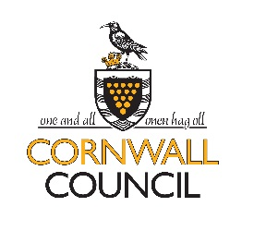
ST WENN, BODMIN, PL30 5PS
Headteacher Mrs S Berry
01726 890405
secretary@st-wenn.cornwall.sch.uk

SCHOOL LUNCH MENU
Week beginning: 4th January and 11th January 2021

 | MONDAY | TUESDAY | WEDNESDAY | THURSDAY | FRIDAY
WEEK BEGINNING
4th Jan | Sausages/vegetarian sausages  Potato wedges  Peas  Ice cream | Pasta and meatballs with tomato sauce  Sweetcorn  Summer fruit and yoghurt | Roast chicken and vegetables  Roast potatoes  Strawberry Mousse | Chicken pie  OR  Veggie pie  Cereal bar | Baked Potatoes with tuna mayonnaise or baked beans or cheddar cheese  Cherry tomatoes and  red peppers  Homemade tray bake
11th Jan | Sausages/vegetarian sausages  Potato wedges  Baked beans  Ice cream | Pasta and meatballs with tomato sauce  Sweetcorn  Strawberry Delight | Roast pork and stuffing  Broccoli  Roast potatoes  Fruit crumble and custard | Mild chicken curry  Rice  Poppadums  Greek yoghurt and fruit coulis | Baked Potatoes with tuna mayonnaise or baked beans or cheddar cheese  Cherry tomatoes and  red peppers  Homemade tray bake

