

St Wenn School
Proposed Admissions policy for 2026/2027
Date of next Review March 2026

Headteacher: Mrs Grace Smith

Chair of Governors: Alix Farquar

General policy statement:
All staff, governors, volunteer helpers, students and visitors need to give due regard to all of the policies and practices adopted by the school. All staff carry responsibility for the welfare and success of the children in our school. Staff will advise anyone who is working alongside us of the necessary protocols, procedures and policies we follow.

Admission arrangements 2026/27
Introduction
St Wenn is a Foundation School and the Governing Board is the Admission Authority for the school.
The school will participate fully in Cornwall Council’s Fair Access Protocol and Cornwall Council’s Co-ordinated Admissions Schemes. Details of these schemes are available on the Council’s website (www.cornwall.gov.uk/admissions) or on request from Cornwall Council. Closing dates and other details about the application process will be stated in those Schemes.
Applying for a place
All applications for places in reception or during the school year must be made direct to the applicant’s home local authority on the appropriate application form. The application form and supporting information will be available on Cornwall Council’s website.
However, if your child has an Education, Health and Care Plan you do not need to complete an application form as a school place will be identified through a separate process.
Allocation of places
Children with an Education, Health and Care Plan that names the school will be admitted regardless of the number on roll in the year group.
Children in Care who are directed to the school by Cornwall Council will be admitted to the school regardless of the number on roll in the year group.
The published admission number (PAN) for reception in 26/27 will be 7. Places will be allocated up to this number. In the event that more applications are received than places available, the oversubscription criteria listed later in this document will be used to decide on allocations. If the school is not oversubscribed, all applicants will be admitted.

Deferred/delayed entry
All children are entitled to start school full-time in the September following their fourth birthday. However, parents may choose deferred or part-time entry to the reception year for their child, bearing in mind that by law children have to be in full-time education by the start of the term following their fifth birthday – when they reach ‘compulsory school age’. Parents of summer-born children may also seek a place for their child outside their normal age group i.e. entry to reception a year later than normal, for example if the child may naturally have fallen into a lower age group if it were not for being born prematurely. Parents choosing part-time or deferred entry or wishing to delay entry to the reception year must contact the Headteacher.]
Admission of children outside their normal age group
Parents may seek a place for their child outside their normal age group, for example, if the child is gifted and talented or has experienced problems such as ill health. Those wishing to request placement outside the normal age group should contact the Headteacher. Such requests will be considered on a case-by-case basis and in the best interests of the child concerned. Guidance can also be found at www.cornwall.gov.uk/admissions or on request from the School Admissions Team. Parents who are refused a place at a school for which they have applied have the right of appeal to an independent admission appeal panel. However, they do not have a right of appeal if they have been offered a place and it is not in the year group they would like.
Appeals
Applicants refused a place at the school have the right of appeal. Appeals are heard by an independent appeals panel [arranged by Cornwall Council on behalf of the Governing Board]. Further details and a timeline can be found in Cornwall Council’s Co-ordinated Admissions Scheme. Applicants can only appeal again for a place in the same school within the same academic year if the admission authority for that school has accepted a further application because there has been a significant and material change in the circumstances of the parent or carer, child or school (e.g. a change of address into a school’s designated area), but has determined that the new application must also be refused.
Waiting lists
If the school is oversubscribed, a waiting list will be held for the whole of the academic year for all year groups and parents/carers can request that their child is added to this list if they are refused a place. The waiting list will be based on the school’s oversubscription criteria and a child’s place on a waiting list is subject to change according to additional information received about applications or children being added to the list – so their place on the list might move up or down. No priority is given to the length of time that a child has been on the list. Children with an Education, Health and Care Plan and children in care or children that were previously in care will take precedence over those on the waiting list. Children admitted under the Fair Access Protocol will also be given priority over children on the waiting list.

Oversubscription Criteria
In the event of there being more than 7 applications for places in reception for the 26/27 academic year or more applications than places for any year group during the school year, the following oversubscription criteria will be used to prioritise applications, after the admission of children whose Education, Health and Care Plan that names the school:
1. Children in care or children that were previously in care but immediately after being looked after became subject to an adoption, child arrangements, or special guardianship order including those who appear (to the admission authority) to have been in state care outside of England and ceased to be in care as a result of being adopted.
2. Children with siblings who will still be attending the school at the time of their admission.
3. Children who live within the designated area of the school, as defined by the Local Authority, or whose parents/carers can provide evidence that they will be living in the designated area of the school by the beginning of the autumn term of the 2026/27 school year.
4. Children with an unequivocal professional recommendation from a doctor, school medical officer, educational psychologist or education welfare officer that non placement at the school would not be in the best interest of the child. Such recommendations must be made in writing and must give full supporting reasons and will be reviewed by the LA.
5. All other children

Notes and definitions
Children in care
A ‘child in care’ may also be referred to as a ‘looked after child’ and is a child who is (a) in the care of a local authority, (b) being provided with accommodation by a local authority in the exercise of their social services functions (see the definition in Section 22(1) of the Children Act 1989).
A ‘child arrangement order’ is an order settling the arrangements to be made as to the person with whom the child is to live under Section 8 of the Children Act 1989. Section 14A of the Children Act 1989 defines a ‘special guardianship order’ as an order appointing one or more individuals to be a child’s special guardian (or special guardians).
A child is regarded as having been in state care outside of England if they were in the care of or were accommodated by a public authority, a religious organisation, or any other provider of care whose sole or main purpose is to benefit society (see Section 23ZZA(8) of the Children Act 1989 (inserted by Section 4 of the Children and Social Work Act 2017)).
Designated areas
Cornwall Council has divided Cornwall into geographical areas. Each of these areas is served by a specific primary school, or in some cases, groups of schools. These areas are called ‘designated areas’ (you may also have heard these areas referred to as ‘catchment’ areas). The designated area used in St Wenn’s oversubscription criteria will be as defined by Cornwall Council. NB: not all schools prioritise on the basis of designated area or use Cornwall Council’s defined area, however, entitlement to home to school transport
will still be based on these areas. Your designated school will not always be the one nearest to your home address. Maps are available for all designated areas online at: www.cornwall.gov.uk/admissions or by calling the School Admissions Team on 0300 1234 101 or emailing: schooladmissions@cornwall.gov.uk.
If you are planning to move into the designated area of St Wenn school, your application for a place for your child will not be given the priority accorded to designated area pupils without firm evidence of your new address and moving date, such as a copy of a signed and dated tenancy agreement or confirmation that contracts have been exchanged.
Children with an unequivocal professional recommendation
Applicants will only be considered under this criterion where the parent/carer can demonstrate that only the preferred school can meet the exceptional medical or social needs of the child, supported by a recommendation from, for example, a doctor, school medical officer or educational psychologist. Such recommendations must be made in writing to the School Admissions Team and must give full supporting reasons. The admission authority will make the final decision on whether or not to accept an application under this criterion.
Siblings
‘Siblings’ means brothers or sisters. They are defined as children with at least one natural or adoptive parent in common, living at the same or a different address. Children living permanently in the same household at the same address would also be counted as siblings, regardless of their actual relationship to each other. To qualify as a sibling a child must be on the roll of or due to be on the roll of the school in question at the date of admission.
If a child is a sibling of a multiple birth (e.g. twins, triplets, etc.) and has been offered a place at the requested school, every effort will be made to offer places to siblings at the same school, which may mean allocating places above the Published Admission Number (PAN) where this is possible. However, where this is not possible, parents will be invited to decide which of the children should be allocated the available place(s).
Tie-breakers
If any of the criteria outlined earlier leave more children with an equal claim than places available, priority will be given to the child who lives nearer to the preferred school.
Final tie-breaker
Should the tie-breakers above still leave children with an equal claim because distances are exactly the same, random allocation will be used to decide on priority. The school will use Cornwall Council’s Random Allocation Protocol, supervised by an independent person, which is available on request.
Distances
Home to school distances used for tie-breaking will be measured by a straight-line measurement as determined by Cornwall Council’s nominated Geographical Information System. Measurements will be between your home address (the centre of the main building of the property) and the main gate of the school (as determined by Cornwall Council).]
Distances used to determine nearest school with room (i.e. where it is not possible to offer a place at a preferred school) and for establishing transport entitlements will be measured by the nearest available route as determined by Cornwall Council’s nominated Geographical Information System software.

Designated Areas
Cornwall Council divides the county into specific geographical zones, each linked to a particular primary school or, in some cases, a cluster of schools. These zones are known as “designated areas” (sometimes referred to as “catchment areas”). For St Wenn School, the designated area used in the oversubscription criteria is the one outlined by Cornwall Council.
It’s important to note that not every school gives priority based on designated areas or uses the council’s definitions. However, eligibility for free home-to-school transport is still determined by these boundaries. Your designated school may not necessarily be the closest one to where you live. The designated area for this school is set out below:
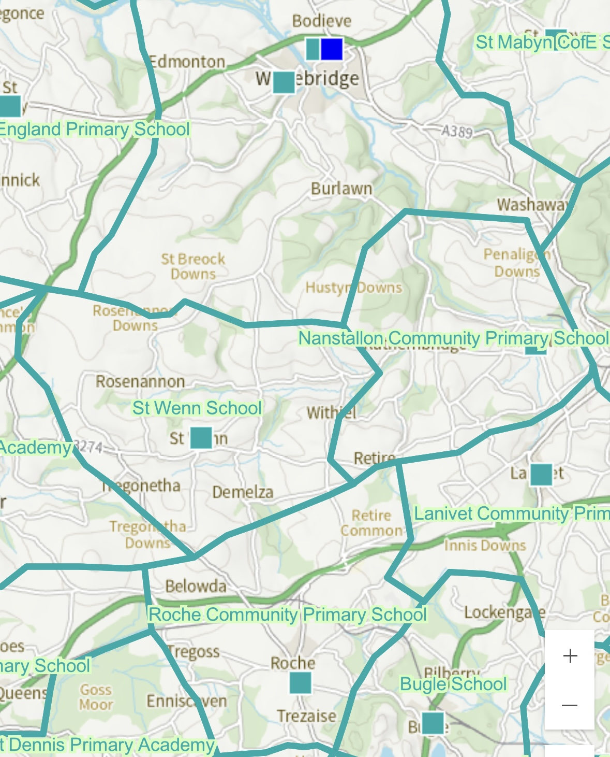
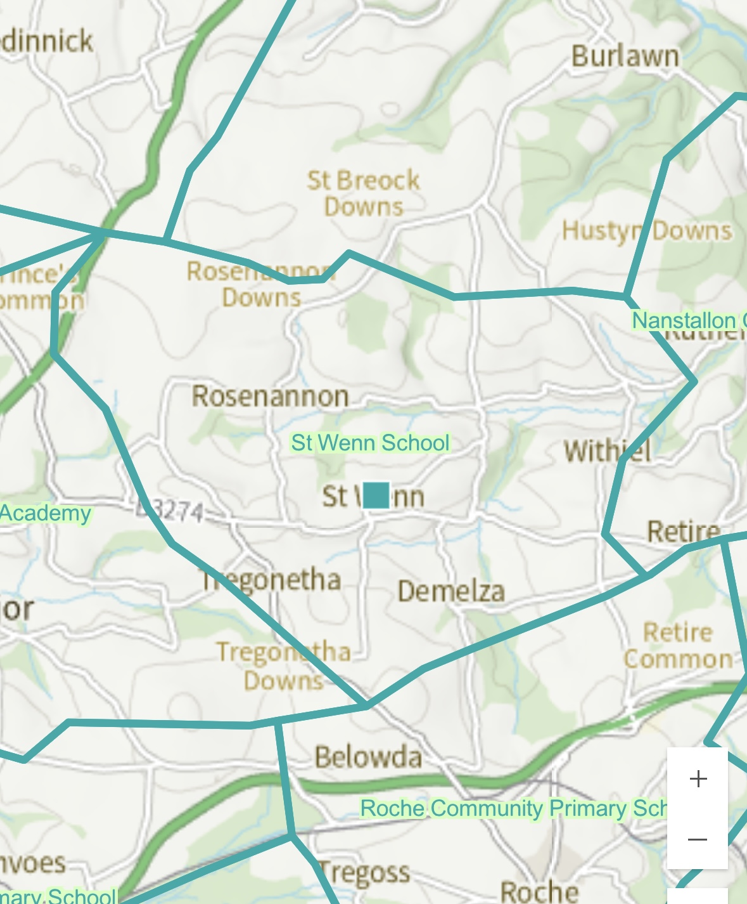

© Crown copyright and database rights 2024 Ordnance Survey AC0000817921 https://map.cornwall.gov.uk/website/ccmap/

If you are intending to move into St Wenn School’s designated area, your child’s application will not be treated as a priority for that area unless you can provide clear proof of your new address and the date of your move. Acceptable evidence includes a signed and dated tenancy agreement or confirmation that contracts have been formally exchanged.

Home address
Each child can have only one registered address for the purposes of determining priority for admission and transport entitlement. This address should be the place where the child is normally resident at the point of application or evidence of the address from which a child will attend school, in the form of written confirmation of a house purchase or a formal tenancy agreement. Exceptional circumstances in relation to the provision of a home address will be considered on a case-by-case basis. If there is shared residence of the child or a query is raised regarding the validity of an address, Cornwall Council will consider the home address to be with the parent with primary day to day care and control of the child. Residency of a child may also be clarified through a Child Arrangement Order where it is shown who has care of the child. Evidence may be requested to show the address to which any Child Benefit is paid and at which the child is registered with a doctor’s surgery.
It is expected that parents will submit only one application for each child. Any disputes in relation to the child’s home address should be settled before applying, the admission authority will not become involved in any parental disputes. If agreement cannot be obtained before an application is made then parents/carers may need to settle the matter through the courts. Where no agreement is reached or order obtained, Cornwall Council will determine the home address.
For information on disputes between persons with parental responsibility in relation to school preferences please see Cornwall Council’s Co-ordinated Admissions Scheme for the relevant year.
Applications for children of Service Families will be processed and places allocated based on the proposed address (with supporting evidence) or, if the family are not able to confirm a proposed address and a unit or quartering address is provided, an allocation will be made based on the unit or quartering address. Until a fixed address is available, the unit postal address or quartering area address will be used to determine allocation of a school place. For the purposes of measuring distances, the main entrance of the unit will be used.

