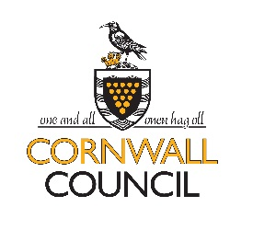
School Emergency Closures

We recognise that the decision to close a school in the event of an emergency (e.g. snow, flooding, no water or heating) significantly impacts upon you, as parents and guardians. This document outlines the agreed procedure which all schools are asked to follow and offers advice to parents on the key things to consider, both before and after the decision to close has been made.

Guidance Given to Schools
Guidance and procedures are sent to all schools on an annual basis, usually at the start of the autumn term. To prevent the possibility of fraudulent school closures, schools are required to follow a verification process before providing school closure information. Schools are then asked to:

*Undertake a risk assessment, using common sense to determine whether it is feasible for children and staff to remain in the school; and if not, what subsequent risks could arise by sending them home. Before school hours, schools are also asked to assess if the roads are safe for children to travel to school.
*Seek approval from the Governing Body (usually the decision of the Chair of Governors will suffice) to authorise the decision to close.
*Notify Cornwall Council and the three local radio stations (BBC Radio Cornwall, Heart FM and Pirate FM). Providing the school follow the agreed procedure, each of the radio stations have agreed to broadcast details of all school closures.

Know Your School’s Procedure
In the case of closure, parents will be contacted by email and updated information will be included on the school website.

Who to Contact?
Should you need to contact the school directly, please be aware that the line may be busy when a large number of parents are calling at the same time.

A full list of all schools closed in Cornwall can be found at:

http://www.cornwall.gov.uk/default.aspx?page=2295

You may also find the following websites useful:
Cornwall Snow Advice
www.cornwall.gov.uk/snow
Met Office
www.metoffice.gov.uk
Environment Agency
www.environment-agency.gov.uk
Devon & Cornwall Police
www.devon-cornwall.police.uk

